Issues observed with R Markdown :

Please consider this while grading :

Step 1 : No MikTex was available, so I downloaded.

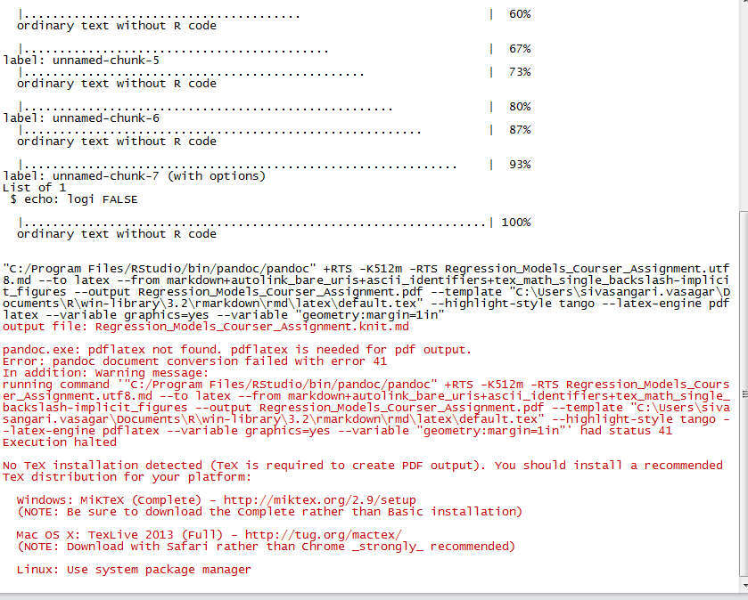

Step 2 : Even after downloading it still didn’t work for me.

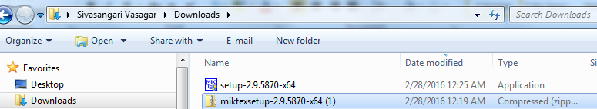

Step 3 : Tried installing pdflatex and got below error.

